

Korea Lunar Exploration Program
DTNPL Technical Description

Date: 29 Oct. 2018 | Doc. No: KPLO-D0-550-100  Issue: 1.0  Total page: 23

Superseding Revised

Prepared By:  June-Tae Park Date  DTN SBC H/W Engineer, Lumir  Min-Woo Park Date  DTN SBC S/W Engineer, Lumir |  | Jeong-Chan Lee Date  DTN SBC Mechanical Engineer, Lumir
Reviewed By:  Chang-Soo Lee Date  DTN SBC Product Assurance, Lumir |  | Dae-Soo Oh Date  DTN SBC Project Manager, Lumir
Kyung-Rak Lee Date
DTN Payload Engineer, ETRI

Approval Signature:  Choel-Oh Jeong Date  DTN Payload Product Assurance, ETRI |  | Jin-Ho Jo Date  DTN Payload Project Leader, ETRI

Original CDMO Release__________________

Revision History
Version | Author(s) |  | Date | Description
0.1 | Jae-Won Jang |  | 2017. 12. 28 | Draft
1.0 | June-Tae Park  Jeong-Chan Lee  Min-Woo Park |  | 2018. 10. 29 | Final

Revision/Change Records
Version | Date | Revision/Change Description | Pages
0.1 | 2017. 12. 28 | Initial | All
1.0 | 2018. 10. 29 | Final | All

Documents Tree

Contents

1. Introduction 8
1.1. Purpose and Scope 8
1.2. Applicable Documents 8
1.2.1. ETRI Documents 8
1.2.2. Other Documents 8
1.3. Abbreviations 8
2. Operation Description 9
2.1. DTN and Space Communications 9
2.2. Mission of DTN Operation 9
2.3. DTN Configurations 9
2.4. Communication Nodes 10
2.4.1. DTN nodes 10
2.4.2. Non-DTN nodes 10
3. System Configuration of DTN Payload 11
4. Technical Description 12
4.1. Functional Block diagram 12
4.2. Major Performance 12
4.3. Electrical Interface 13
4.3.1. Power Interface 13
4.3.2. Communication Interface 14
4.3.3. House Keeping Design 17
4.4. EEE Parts List 18
4.5. FPGA Design 19
4.6. Schematic Design 21
4.7. PCB artwork 22

Figures

Figure 2-1 DTN test configuration in the first phase 10
Figure 3-1 Interface diagram of DTN payload 11
Figure 4-1 DTNPL Functional Block Daigram 12
Figure 4-2 Power Interface 14
Figure 4-3 Power Connetor Location 14
Figure 4-4 TM/TC UART Interface Scheme 15
Figure 4-5 TM Bi-level Interface Scheme 15
Figure 4-6 TC Bi-level Interface Scheme 16
Figure 4-7 Data Downlink Interface Scheme 16
Figure 4-8 Communication Connector Location 17
Figure 4-9 House Keeping Scheme 18
Figure 4-10 FPGA Block Diagram 19
Figure 4-11 Schematic Design 21
Figure 4-12 Artwork 22

Tables

Table 4-1 DTNPL Major Performance 12
Table 4-2 DTNPL Electrical Interface 13
Table 4-3 Power Connector Pin Map 14
Table 4-4 TM/TC UART Interface Description 15
Table 4-5 TM/TC Bi-level Interface Description 15
Table 4-6 Data Downlink Interface Description 16
Table 4-7 Communication Connector Pin Map 17
Table 4-8 DTNPL Parts List 19
Table 4-9 FPGA Function Description 20
Table 4-10 FPGA Gate Estimation 21
Table 4-11 Schematic Description 22
Table 4-12 PCB Stack Up Information 23

Introduction

Purpose and Scope
This document describes the system specifications of DTN payload for Korea lunar exploration program.

Applicable Documents

ETRI Documents
Document Number | Document Title
KPLO-D0-551-002 | Operation Scenario of DTN
KPLO-D0-550-000 | System Requirements of DTN Payload

Other Documents
Document Number | Document Title
KPLO-SP-300-002 | KPLO System Requirements Document

Abbreviations
AMS | Asynchronous Message Service
AOS | Advanced Orbiting System
BP | Bundle Protocol
BSS | Bundle Streaming Service
CCSDS | Consultative Committee for Space Data Systems
CFDP | CCSDS File Delivery Protocol
DCC | DTN Control Center
DTN | Delay(Disruption) Tolerant Network
DTNPL | DTN Payload
IP | Internet Protocol
KPLO | Korea Pathfinder Lunar Orbiter
LCM | Lander Communication Model
LTP | Licklider Transmission Protocol
M&C | Monitor & Control
RCM | Rover Communication Model
SLE | Space Link Extension
TBC | To Be Confirmed
TBD | To Be Defined
TCP | Transmission Control Protocol
UDP | User Datagram Protocol

Operation Description

DTN and Space Communications
Delay/disruption tolerant networking (DTN) technology offers a new solution to highly stressed communications in space environments, especially those with long link delay and frequent link disruptions in deep space missions. Delay/disruption tolerant networking (DTN) technology offers a new solution that use a store-and-forward mechanism to combat long link delay and frequent link disruptions generally characterizing space communications. DTN communications use a bundle protocol (BP), to construct a store-and-forward overlay network. The BP, situated at the application layer of the Internet model, utilizes conventional Internet protocols to send and receive data bundles. The benefits of DTN communications are as follows.
- Interoperability and Reuse: A standardized DTN protocol suite enables interoperability of multi-agency communication assets and also allows NASA to use the same communication stack for future missions (LEO, NEO or Deep Space).
- Space Link Efficiency, Utilization and Robustness: DTN enables more reliable and efficient data transmissions resulting in more usable bandwidth. DTN also improves link reliability by having multiple network paths and assets for potential communication hops.
- Security: The DTN Bundle Security Protocol (BSP) allows for integrity checks, authentication and encryption, even on links where not previously used.
- Quality of Service: The DTN protocol suite allows for many priority levels to be set for different data types, ensuring that the most important data is received ahead of less important data.
- Improved Operations and Situational Awareness: The DTN store-and-forward mechanism along with automatic retransmission provides more insight into events during communication outages and significantly reduces the need for ground-based scheduling.

Mission of DTN Operation
The mission of DTN is to validate DTN communication protocols by space link testing through KPLO. So DTN operations are focused on testing the DTN protocols using KPLO space links.

DTN Configurations
In the first phase of lunar exploration, test lunar orbiter called Korea Pathfinder Lunar Orbiter (KPLO) will be launched without lunar lander. Figure 2.1 shows DTN configuration in first phase of lunar exploration. There are no Lander and Rover on the moon in first phase. So Lander Communication Mode (LCM) and Rover Communication Mode (RCM) will be located on earth for the DTN communication testing.
DTN Payload (DTNPL) is a DTN node in the space. DTNPL will be mounted on the KPLO for DTN communication. DTN Control Center (DCC) is a control center of DTN communication nodes. LCM and RCM are DTN nodes on ground. All DTN nodes on ground are interconnected by the terrestrial network such as Internet. MCC and DSN are not DTN nodes. They just transfer DTN packets to next communication nodes.

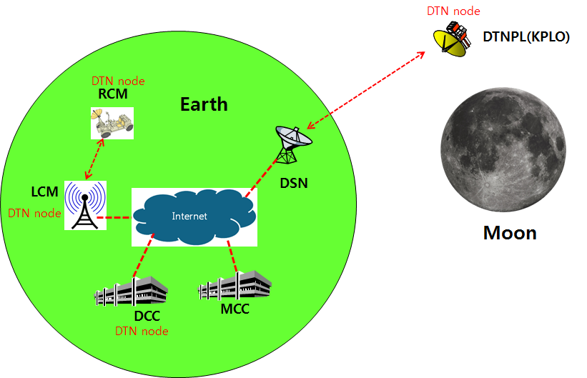
Figure 2-1 DTN test configuration in the first phase

Communication Nodes
Many communication nodes are needed for the DTN operation. Some of communication nodes in the network are DTN nodes whereas otherwise nodes are non-DTN nodes. The function of communication nodes used in the DTN operation is as follows.

DTN nodes
- DCC is a ground DTN node which monitor and controls DTN nodes. DCC send commands to DTN nodes such as DTNPL, LCM and RCM. It also receives telemetries or acquired data from some DTN nodes such as RCM or LCM.
- DTNPL is a DTN node mounted on the KPLO. DTNPL can be operated as a DTN end point. And it also can be operated as relay nodes which relay DTN data between DCC and RCM or LCM.
- LCM is a ground DTN node. LCM relays DTN data between MCC and RCM.
- RCM is a ground DTN node and a DTN end point. The commands sent by the DCC is terminated at the RCM and the RCM returns telemetry or data to DCC through KPLO.

Non-DTN nodes
- MCC is a non-DTN node. MCC monitors and controls KPLO and payloads. MCC also receives and processes data generated from the payloads and transfers to each payload control center.
- DSN is a ground station for deep space communication. DSN will have a big size of antenna and RF equipment for space link interface. DSN also have network equipment for terrestrial communication interface such as SLE link. DSN is a non-DTN node.

System Configuration of DTN Payload

The DTN payload shall have interface with KPLO for the operational power supply and for the communications. The following figure shows DTN payload interface diagram with KPLO.

Figure 3-1 Interface diagram of DTN payload

There are four kinds of interface types between DTNPL and KPLO. Each interface types are described as following.
- TM/TC (bi-level): One bi-level TC and one bi-level TM for DTNPL emergency operation.
- Bi-level TC: System reset command in the emergence condition
- Bi-level TM: Telemetry showing that DTNPL is in alive
- TM/TC (UART): Serial communication channel for TM/TC communication with KPLO SBMU
- Data downlink: Serial data downlink channel to KPLO PDHU
- Power: Operation DC power +28V from the KPLO PCDU

Technical Description

Functional Block diagram
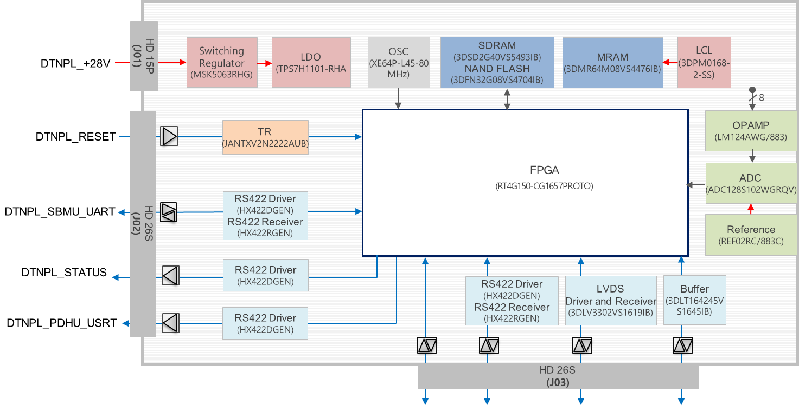
Figure 4-1 DTNPL Functional Block Daigram

Major Performance
Table 4-1 DTNPL Major Performance
Item | Design Specification | Specifications
Processor | 32-bit Leon3
OS | RTEMS v4.11
Memory | 64 Mbits for Booting and Program
Memory | 2.5 Gbits for Code Execution
Memory | 4 GB (Non Volatile) for Mission Data | > 2 GB
TM/TC (SBMU I/F) | DMA_UART (RS422) | DMA_UART (RS422)
Downlink (PDHU I/F) | USRT (RS422) | USRT (RS422)
Analog I/F | 8 ch | 8 ch
Input Power | 28 V Unregulated  (20 VDC ~ 40 VDC) | 28 V Unregulated  (24 VDC ~ 32.8 VDC)
Power Consumption | <6 W | < 12 W
Mass | < 1 kg | < 2 kg
Size (WxLxH) | 120 x 170 x 39 mm | < 120 x 170 x 50 mm
Reliability | 0.878063 (Analyzed) | > 0.7
Debug | 1EA: JTAG (Firmware Uploader)  1EA: RS422 (Debugging UART)  1EA: SpaceWire (Image Uploader)  4EA: GPIO (Test)  1EA: SPI (S/W 동적테스트 장비(DT10) 연동)

Electrical Interface
Table 4-2 DTNPL Electrical Interface
 | Type | Mnemonic | Physical I/F | Direction | Description | Connector
Power | +28V | DTNPL_+28V | Nominal +28Vdc | Bus (PCDU) DTNPL | DTN Power | CON_PWR
TM/TC | Bi-level TM | DTNPL_STATUS | Bi-level TM  - Logic LOW : 0V  - Logic HIGH : 5V | Bus (SBMU) DTNPL | 0.25 Hz  Heartbeat | CON_COMM
TM/TC | Bi-level TC | DTNPL_RESET | Bi-level TC  - Logic LOW : 0V  - Logic HIGH : 5V | Bus (SBMU) DTNPL | DTN Run (0V)  DTN Reset (5V) | CON_COMM
TM/TC  (SBMU) | DMA_UART | DTNPL_SBMU_UART | RS422 Differential | Bus (SBMU) DTNPL | 115.2 kbps | CON_COMM
Data downlink  (PDHU) | USRT | DTNPL_PDHU_USRT | RS422 Differential | Bus (PDHU) DTNPL | 2.0 Mbps | CON_COMM

Power Interface
The DTNPL has the DC power interface to get operation power from the KPLO (nominal +28Vdc). Secondary power values of DTNPL are 3.3V, 2.5V, 1.8V, 1.2V and 5V for precision voltage reference.

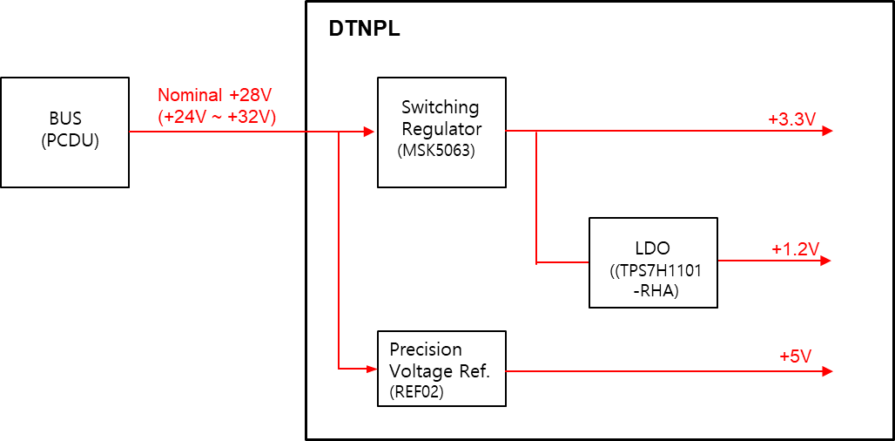
Figure 4-2 Power Interface

Table 4-3 Power Connector Pin Map
High Density D-SUB 15-Pin (Male) Allocation List
Pin | Description | Pin | Description | Pin | Description
1 | DTNPL_+28V | 6 | (Reserved) | 11 | DTNPL_+28V_rtn
2 | DTNPL_+28V | 7 | (Reserved) | 12 | DTNPL_+28V_rtn
3 | DTNPL_+28V | 8 | (Reserved) | 13 | DTNPL_+28V_rtn
4 | DTNPL_+28V | 9 | (Reserved) | 14 | DTNPL_+28V_rtn
5 | DTNPL_+28V | 10 | (Reserved) | 15 | DTNPL_+28V_rtn
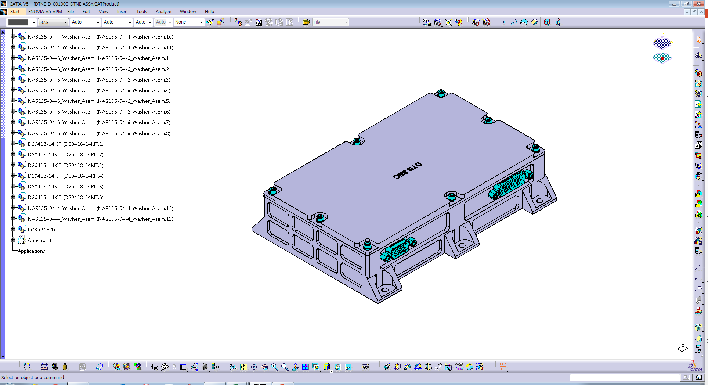
Figure 4-3 Power Connetor Location
CON_PWR

Communication Interface
The DTNPL has 1 UART for SBMU, 1 Bi-level for Status, 1 Bi-level for Command and 2 USART for PDHU(p/r).
TM/TC (DMC UART) interface is as below.
Table 4-4 TM/TC UART Interface Description
Type | DMA_UART
Mnemonic | DTNPL_SBMU_UART
Physical I/F | RS422 Differential
Direction | Bus(SBMU) DTNPL(SBC)
Description | 115.2 kbps Echo back

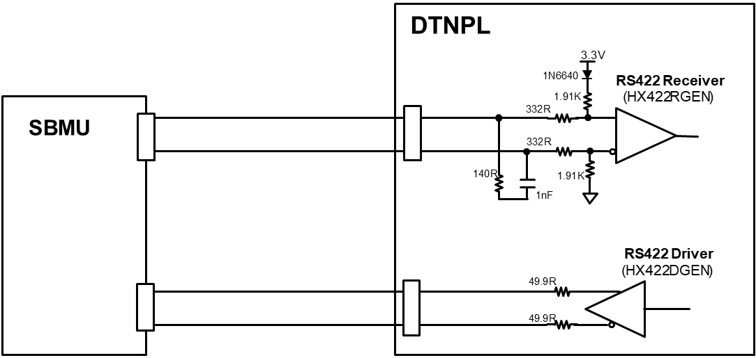
Figure 4-4 TM/TC UART Interface Scheme

TM/TC (Bi-level) interface is as below.
Table 4-5 TM/TC Bi-level Interface Description
Type | Bi-level TM | Bi-level TC
Mnemonic | DTNPL_STATUS | DTNPL_RESET
Physical I/F | Logic LOW: 0V  Logic HIGH: 5V | Logic LOW: 0V  Logic HIGH: 5V
Direction | Bus(SBMU) DTNPL(SBC) | Bus(SBMU) DTNPL(SBC)
Description | 0.25 Hz  Heartbeat | DTN Run (0V, Default)  DTN Reset (5V)

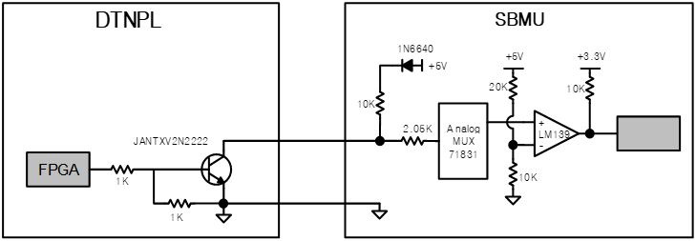
Figure 4-5 TM Bi-level Interface Scheme

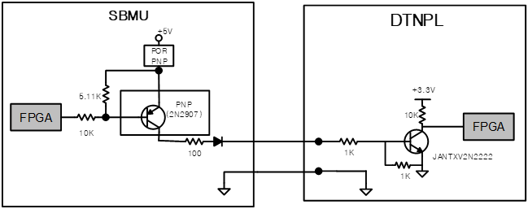
Figure 4-6 TC Bi-level Interface Scheme

Data downlink interface with PDHU is as below.
Table 4-6 Data Downlink Interface Description
Type | USART
Mnemonic | DTNPL_PDHU_UART
Physical I/F | RS422 Differential
Direction | Bus(PDHU) DTNPL(SBC)
Description | 2.0 Mbps

Figure 4-7 Data Downlink Interface Scheme

Table 4-7 Communication Connector Pin Map
Pin | Description | Pin | Description
1 | DTNPL_JTAG_TDI | 14 | DTNPL_DBG_SpW_RxDp
2 | DTNPL_JTAG_TDO | 15 | DTNPL_DBG_SpW_RxDn
3 | DTNPL_JTAG_TCK | 16 | DTNPL_DBG_SpW_RxSp
4 | DTNPL_JTAG_TMS | 17 | DTNPL_DBG_SpW_RxSn
5 | DTNPL_JTAG_TRSTB | 18 | DTNPL_GPIO
6 | DTNPL_JTAG_GND | 19 | DTNPL_UART422_TXp
7 | DTNPL_JTAG_GND | 20 | DTNPL_UART422_TXn
8 | DTNPL_JTAG_+3.3V | 21 | DTNPL_UART422_RXp
9 | DTNPL_JTAG_+3.3V | 22 | DTNPL_UART422_RXn
10 | DTNPL_DBG_SpW_TxDp | 23 | DTNPL_DT10_SCK
11 | DTNPL_DBG_SpW_TxDn | 24 | DTNPL_DT10_SDI
12 | DTNPL_DBG_SpW_TxSp | 25 | DTNPL_DT10_nCS
13 | DTNPL_DBG_SpW_TxSn | 26 | DTNPL_DT10_CNG

Figure 4-8 Communication Connector Location
CON_COMM

House Keeping Design
The DTNPL has a function of the House Keeping as below.
- Power consumption monitoring (+28V current)
- Input voltage monitoring (+28V voltage)
- Secondary voltage monitoring (+3.3V voltage)
- FPGA core voltage monitoring (+1.2V voltage)
- FPGA temperature monitoring
- Board temperature monitoring

If abnormal case, DTNPL does
- Stores H.K data to NAND flash(Black box area)
- Goes to Standby mode
- Does NOT send heartbeat to SBMU (0.25Hz 0Hz)
Figure 4-9 House Keeping Scheme

EEE Parts List

Table 4-8 DTNPL Parts List
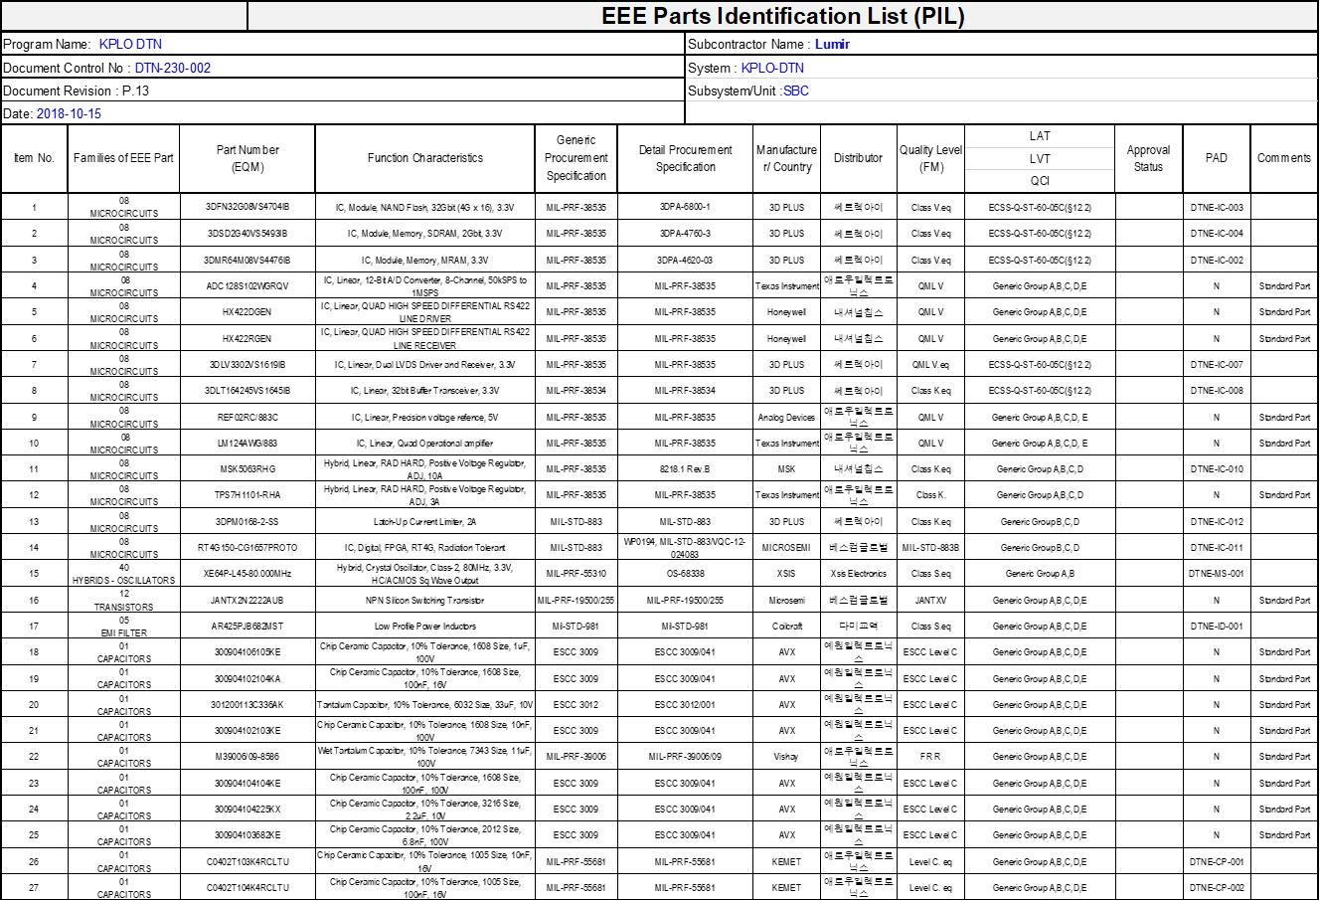
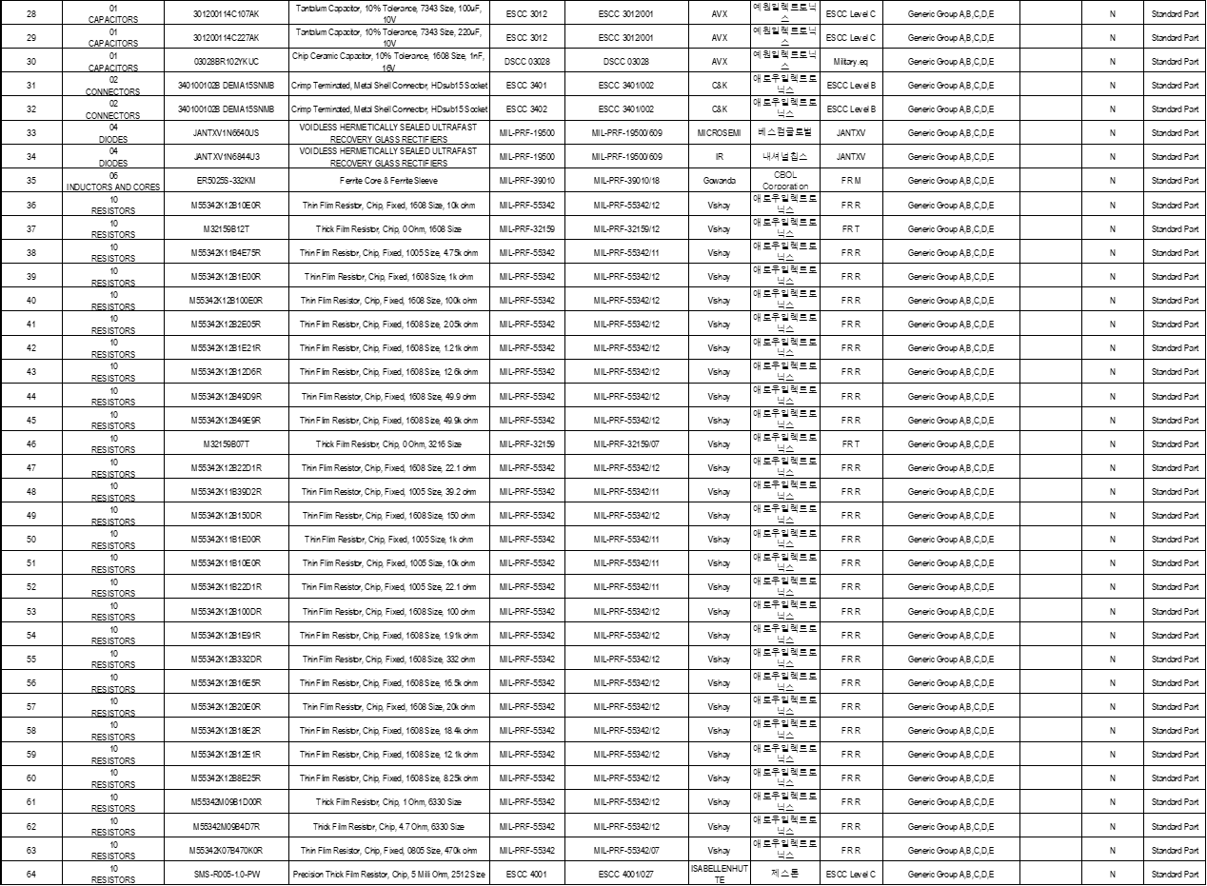

FPGA Design

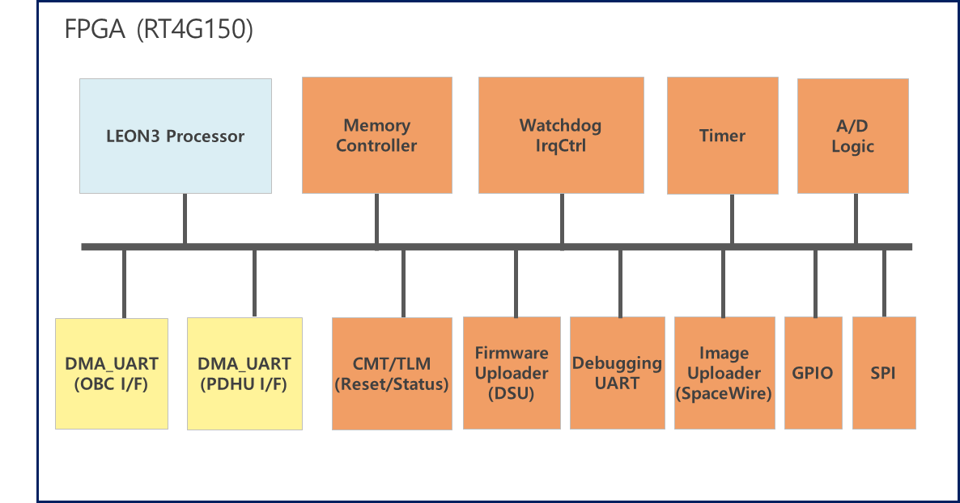
Figure 4-10 FPGA Block Diagram
Table 4-9 FPGA Function Description
FPGA IP | Description
LEON3 | 32-bit Leon3 Processor
AHBCTRL | AHB Controller
APBCTRL | APB Controller
APBUART | UART Controller using APB Bus
DSU | Debugging Support Unit
DMA_UART | UART Controller for TM/TC I/F
USRT | USRT Controller for PDHU I/F
Memory Controller | Memory Controller
Watchdog, IRQ CTRL | System monitoring and status informing
GPIO | General Purpose I/O Control
Timer | Timing Synchronization
A/D Logic | Convert Analog to Digital Block
Firmware Uploader | LEON3 S/W Uploader

Table 4-10 FPGA Gate
IP Core | Vendor | Description | 크기 |  | 개  수 | 크기합계
IP Core | Vendor | Description | Cell | RAM  24K | 개  수 | Cell | RAM  24K
LEON3 | Gaisler | 32-bit Leon3 Processor | 5900 | 75 | 1 | 5900 | 75
AHBCTRL | Gaisler | AHB Controller | 600 | 0 | 1 | 600 | 0
APBCTRL | Gaisler | APB Controller | 400 | 0 | 1 | 400 | 0
APBUART | Gaisler | UART Controller using APB BUS | 350 | 0 | 1 | 350 | 0
DSU | Gailser | Debugging Support Unit | 1100 | 2 | 1 | 1100 | 2
DMA_UART | Lumir | DMA Controller for TM/TC I/F | 450 | 0 | 1 | 450 | 0
USRT | Lumir | USRT Controller for PDHU I/F | 450 | 0 | 1 | 450 | 0
Memory Controller | Gaisler | Memory controller | 3,200 | 50 | 1 | 3,200 | 50
Watchdog,  IRQ CTRL | Gaisler | System monitoring and status informing | 340 | 0 | 1 | 340 | 0
GPIO | Gaisler | General Purpose I/O Control | 390 | 0 | 1 | 390 | 0
Time Sync | Lumir | Timing Synchronization according to PPS | 220 | 0 | 1 | 220 | 0
A/D Logic | Lumir | Convert Analog to Digital Block | 1610 | 2 | 1 | 1610 | 2
Firmware Uploader | Lumir | LEON3 S/W Uploader | 2040 | 5 | 1 | 2040 | 5
합계 |  |  |  |  |  | 17,950 | 134
RT4G150 Cell Capacity |  |  |  |  |  | 180,728 | 239
FPGA 전체 점유율 |  |  |  |  |  | 10% | 56%

Schematic Design
- Design tool : Altium 16.1.7
- Total 15 sheets
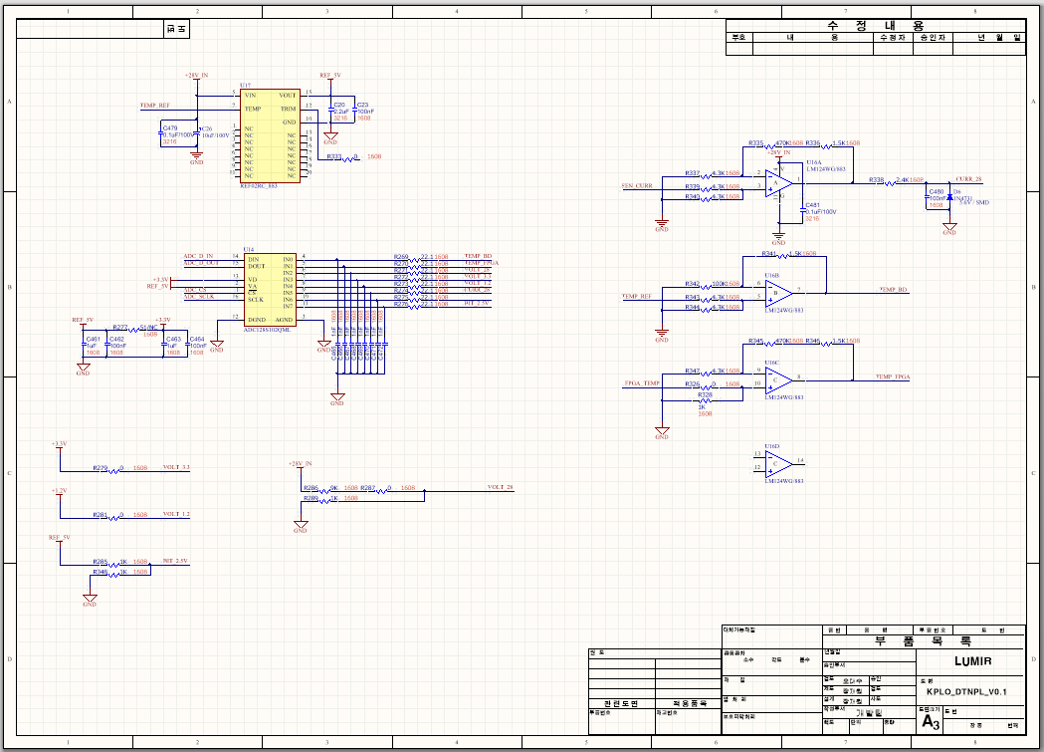
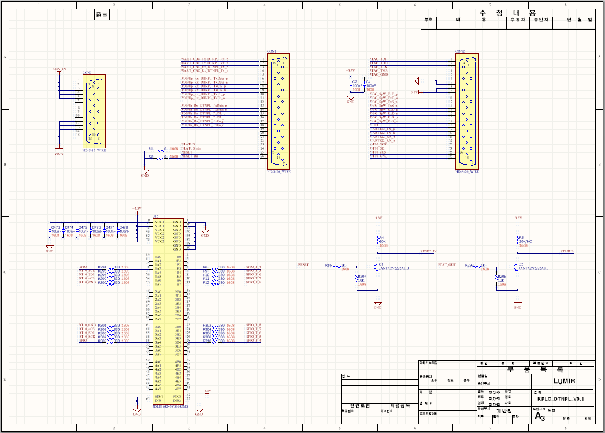
Figure 4-11 Schematic Design
Table 4-11 Schematic Description
Sheet # | Title | Description
0 | Cover | Board Information
1 | Connectors | External connectors and Buffer
2 | POWERCLK | Regulator, OSC
3 | FPGA_B0B1 | FPGA Bank0, Bank1
4 | FPGA_B2B4 | FPGA Bank2, Bank4
5 | FPGA_B5B6 | FPGA Bank5, Bank6
6 | FPGA_B7B8 | FPGA Bank7, Bank8
7 | FPGA_B9JTAG | FPGA Bank9 JTAG Reset
8 | FPGA_SERDES | FPGA SERDES
9 | FPGA_PWR | FPGA PWR for Core, SERDES, PLL
10 | FPGA_PWR2 | FPGA PWR for Bank IO
11 | FPGA_GNDNC | FPGA GND and NC
12 | MEMORY | SRAM, MRAM, Flash
13 | IF_INT | LVDS, 422
14 | ALGMUX_ADC | ADC MUX, OPAMP

PCB artwork
- Design tool : Altium 16.1.7
- PCB size : 158mm X 88mm X 2T
- 10 layers
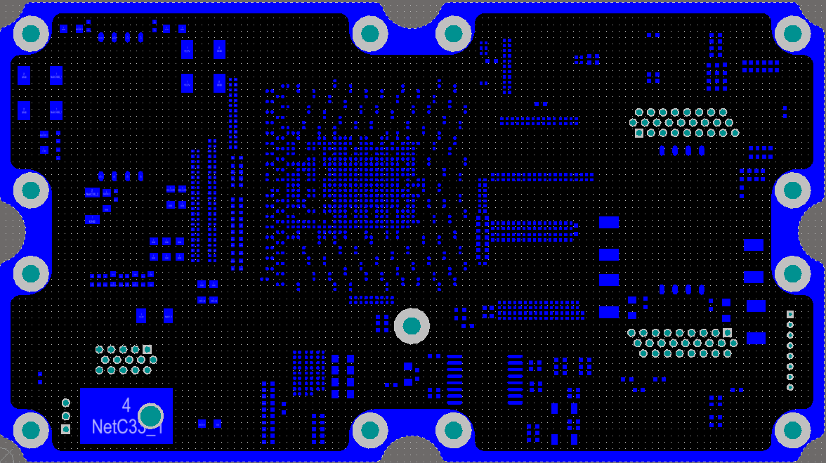
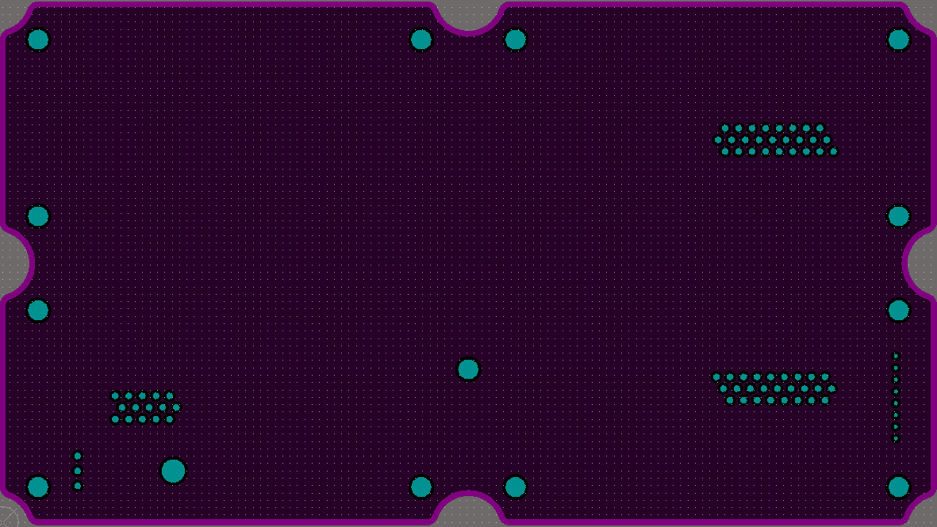
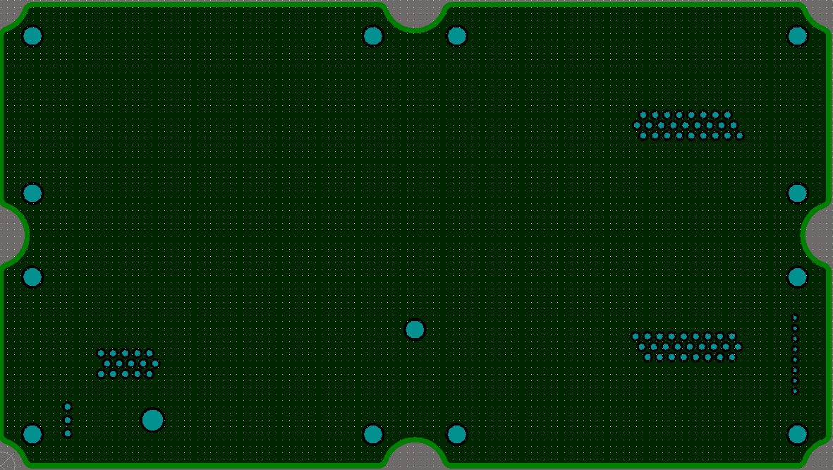
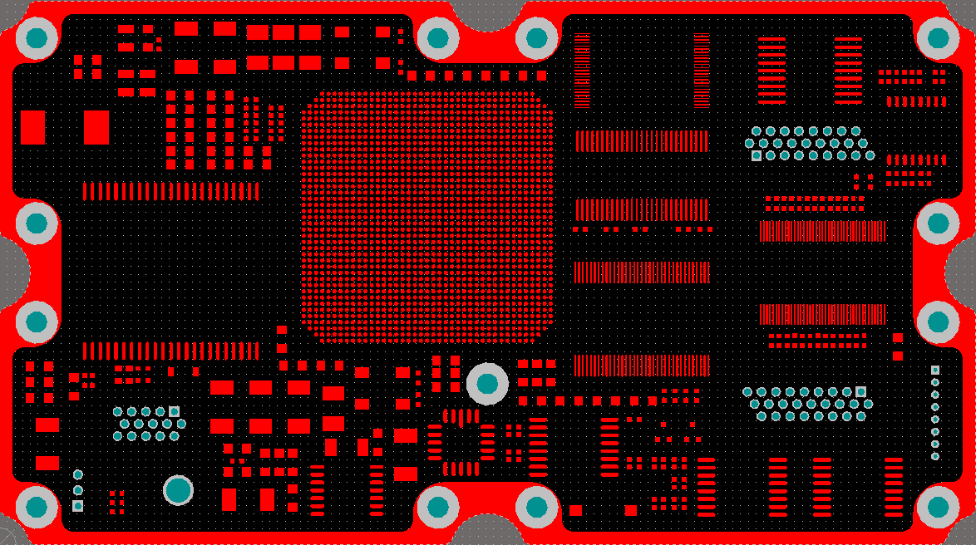
- Polyimide
Figure 4-12 Artwork

Table 4-12 PCB Stack Up Information
STACK UP |  |  | 50옴 임피던스 |  | 100옴 임피던스
층 | 적층 | 예상두께 | 회로폭(㎛) | 보정후 | 회로폭(㎛) | 간격(㎛) | 보정회로폭 | 보정후 간격
1 | 1/2 OZ COPPER | 42 ㎛ | 100 | 130 | 90 | 260 | 120 | 230
 | 0.06X1 | 60 ㎛
2 | 1 OZ COPPER | 35 ㎛ | REFERENCE |  | REFERENCE
 | 0.3T | 300 ㎛
3 | 1 OZ COPPER | 17 ㎛ | 114 | 144 | 92 | 220 | 122 | 190
 | 0.11X1 | 110 ㎛
4 | 1 OZ COPPER | 35 ㎛ | REFERENCE |  | REFERENCE
 | 0.3T | 300 ㎛
5 | 1 OZ COPPER | 35 ㎛ | 114 | 144 | 92 | 220 | 122 | 190
 | 0.11X1 | 110 ㎛
6 | 1 OZ COPPER | 35 ㎛ | REFERENCE |  | REFERENCE
 | 0.3T | 300 ㎛
7 | 1 OZ COPPER | 35 ㎛ | REFERENCE |  | REFERENCE
 | 0.11X1 | 110 ㎛
8 | 1 OZ COPPER | 35 ㎛ | 114 | 144 | 92 | 220 | 122 | 190
 | 0.3T | 300 ㎛
9 | 1 OZ COPPER | 35 ㎛ | REFERENCE |  | REFERENCE
 | 0.06X1 | 60 ㎛
10 | 1/2 OZ COPPER | 42 ㎛ | 100 | 130 | 90 | 260 | 120 | 230
TOTAL |  | 1,996 ㎛

